ABDUL HASEEB
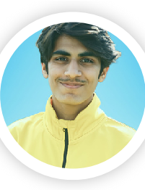

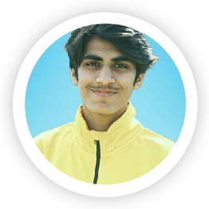

KHAN
Front-end Back-
end developer
03420529206 haseebkhan645411@gmail.c
om
haseeb khan (Linkdin)
haseebszabist (Github)
EDUCATION PROFILE
I am currently a seventh-semester student at SZABIST University Bachelor in Computer
Islamabad, with a strong passion for design and development. I am Science (UG)
actively seeking both on-site and off-site opportunities to expand my Szabist University H-8/4
islamabad skill set and gain new knowledge. My goal is to refine my abilities to
2021
align with my future aspirations, while embracing the learning process
FSC : Pre-Engineering and adapting to various environments
KIPS College G-9 Islamabad
2018 - 2020 WORK EXPERIENCE
Matric : Computer
Fiverr.com 2020 – 2025
Science
pixel animator
Fazaia Inter College E-9
Working as an 2d-animator in pixel art and game assets .
Islamabad
working on fiverr since 2020 2016 - 2018
Transcription 2023
SKILLS
Translator
C++
Worked as an translator to translate dramas,series,films in C
different language . html
converting audio clips into subtitles. css
Bootstrap
React
CERTIFICATION
Javascript
Java (GUI,Oop) 2024 NAVTTC
Node.js
full stack developer
Sql
done 3-months full stack course with the company
swyft
leadership.com.
Python
Kotlin 2024 GOOGLE
2d-pixel animation
google ads
2d-pixel game assets
done 1-month google ads campaign.
running google campaign ads on e-mails,youtube
LANGUAGE
intervals,poster ads.
English
German (Learning)
French

